# *PROJECT REPORT: -* *INTERNSHIP: TATA TECHNOLOGIES*

***“Tata-Connect”***

***Inter-Organizational Community***

***Building Platform***

**Prepared By:** *Devanshu Singh*

**Employee Id:** *775182**(Intern)*

**Supervised By:** *Mr. Rajesh Roshan (Team Lead)*

**Date:** *01-06-2024 to 31-07-2024*

**University:** *Manipal Institute of Technology, Manipal*

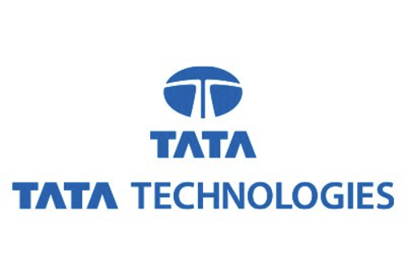

# ACKNOWLEDGEMENT

I am immensely grateful for the opportunity to have completed my internship at Tata Technologies Ltd, a platform that not only allowed me to hone my professional skills but also to contribute to a meaningful project. The experience has been invaluable and has significantly contributed to my personal and professional growth.

I would like to extend my heartfelt thanks to Mr. Rajesh Roshan for his exceptional guidance and mentorship. Their expertise, patience, and encouragement were instrumental in navigating the challenges encountered during the project. Their insights not only steered the project towards success but also enriched my understanding and approach towards complex problem- solving.

The support and collaboration provided by the entire team at Tata Technologies Ltd have been nothing short of extraordinary. Working alongside such talented and dedicated professionals has been a truly enlightening experience. Their willingness to share knowledge and offer assistance played a significant role in the successful completion of my internship project.

Additionally, I am profoundly thankful to my alma mater, Manipal Institute of Technology, for providing me with the foundational knowledge and skills that have been crucial in this endeavour. The education and training I received there have been fundamental in preparing me for the real-world challenges of this internship. I am proud to carry forward the values and learnings instilled by the institution into my professional journey.

Finally, I extend my appreciation to all those who directly or indirectly contributed to my project. The journey has been a tapestry of learning, overcoming challenges, and achieving milestones, and it would not have been possible without the collective support and collaborative spirit of everyone involved.

1. **Executive Summary**

# CONTENTS

* 1. Addressing Current Challenges
  2. Key Features and Advantages
  3. Future Prospects
  4. Conclusion

## Industry Overview: Tata Technologies

* 1. Company Profile
  2. Market Position and Technological Trends
  3. Corporate Philosophy and Values

## Design Principles and Advanced Functionalities

* 1. User-First Design Philosophy
  2. Code-First Approach in Development
  3. Responsive Design
  4. Modular Architecture
  5. Security
  6. Performance
  7. CICD
  8. Scalablity

## Workflow of the Application

## Workflow of the Deployment

## Skills and Technologies Learnt and Implemented

* 1. Front-End Technologies: React and Jquery
  2. Back-End Technologies: NodeJS and MySQL
  3. Deployment: AWS and Terraform (IaC)

## Use Cases of "Tata-Connect"

## Test Case Table

* 1. Tabulated format of the test cases conducted on the Project.

## Conclusion

* 1. Project Summary

# EXECUTIVE SUMMARY

The TATA-Connect project is a pioneering initiative aimed at revolutionizing the internal communication landscape within Tata Technologies by replacing the poorly utilized Viva-Engage platform. This proof-of-concept project seeks to establish a homegrown solution that not only enhances communication but also streamlines the dissemination of information across the organization.

### ***Addressing Current Challenges:***

The existing platform, Viva-Engage, has failed to meet the communication needs of the organization effectively, leading to an over-reliance on email for sharing even non-essential information. This has resulted in cluttered inboxes and inefficient communication channels. TATA-Connect addresses these issues by providing a centralized platform where information can be shared as posts, accessible to all members within a specific department. This approach significantly reduces the load on the email system, ensuring that only critical information is sent via email, while other communications are seamlessly managed through TATA-Connect.

### ***Key Features and Advantages:***

1. **Centralized Information Sharing:** TATA-Connect allows users to post updates, announcements, and information directly to a department-specific feed. This ensures that all relevant personnel have access to the same information at the same time, fostering a more informed and cohesive workforce.
2. **User-Friendly Interface:** The platform is designed with a user-first approach, ensuring simplicity and ease of use. This encourages higher adoption rates and better user engagement compared to Viva-Engage.
3. **Iterative Waterfall Model:** The development of TATA-Connect follows an iterative waterfall model. This approach allows for the systematic and phased development of the platform, ensuring that each version builds upon the successes and learnings of the previous iterations. Version one of TATA-Connect lays a robust foundation, and subsequent versions can be rolled out with enhanced features and performance improvements.
4. **CI/CD Pipeline:** To support the iterative development process, a Continuous Integration and Continuous Deployment (CI/CD) pipeline has been established. This pipeline facilitates the seamless integration of new features and updates, ensuring that the platform remains agile and responsive to user needs. It allows for rapid deployment of improvements and bug fixes, thereby enhancing the overall user experience.
5. **Scalability and Flexibility:** As a homegrown solution, TATA-Connect is highly customizable and scalable. It can be tailored to meet the specific needs of Tata Technologies, ensuring that the platform evolves in alignment with organizational goals and user feedback.

### ***Future Prospects:***

The implementation of TATA-Connect marks a significant step towards modernizing internal communication at Tata Technologies. By reducing dependency on email and providing a more efficient platform for information sharing, TATA-Connect promises to enhance productivity and collaboration. Future iterations will focus on incorporating advanced features such as integration with other enterprise tools, enhanced security measures, and improved user analytics to provide deeper insights into communication patterns.

### ***Conclusion:***

TATA-Connect represents a strategic initiative to replace Viva-Engage with a more effective and user-friendly platform. Its iterative development process, supported by a robust CI/CD pipeline, ensures that it will continually evolve to meet the dynamic needs of the organization. By centralizing communication and reducing the load on the email system, TATA-Connect is poised to significantly enhance the efficiency and effectiveness of internal communications at Tata Technologies.

# INDUSTRY OVERVIEW: TATA TECHNOLOGIES

Tata Technologies Ltd, a part of the prestigious Tata Group, is a global leader in engineering and product development IT services. Established in 1989, the company has been at the forefront of innovation in the engineering and automotive industries. With a strong focus on the manufacturing sector, Tata Technologies provides comprehensive solutions in engineering, research and development, and product lifecycle management.

Operating in a highly dynamic and competitive industry, Tata Technologies sets itself apart through its deep commitment to technological innovation and customer-centric solutions. The company serves a diverse range of clients, from start-ups to established industry giants, offering services that span from concept to product launch. This includes areas such as vehicle development, aerospace design, and industrial machinery.

As a global enterprise, Tata Technologies has a significant presence in regions including North America, Europe, and the Asia-Pacific, employing over 8,000 professionals worldwide. The company's global reach and diverse talent pool allow it to deliver high-quality, cost-effective solutions that cater to the specific needs of clients in various geographic markets.

In recent years, Tata Technologies has been increasingly focusing on digital technologies such as IoT (Internet of Things), AI (Artificial Intelligence), and cloud computing to drive innovation and efficiency in the engineering sector. These technological advancements have enabled the company to offer more integrated and intelligent solutions, further solidifying its position as an industry leader.

Tata Technologies is also known for its commitment to sustainability and corporate social responsibility. The company's initiatives focus on environmental conservation, education, and community development, aligning with the broader values and ethos of the Tata Group.

In summary, Tata Technologies Ltd represents a fusion of technical expertise, innovation, and global reach, making it a key player in the engineering and product development IT services industry. The company's dedication to cutting-edge technology, customer service, and social responsibility continues to drive its growth and success in the global market.

# DESIGN PRINCIPLES AND ADVANCED FUNCTIONALITIES

### ***User-First Design Philosophy:***

At the core of TATA-Connect is a User-First Design Philosophy. This principle prioritizes simplicity and accessibility, ensuring the platform is intuitive and easy to use for all employees, regardless of their technical proficiency.

* **Intuitive Interface:** The user interface is designed to be clean and straightforward, allowing users to navigate the platform easily without extensive training.
* **Accessibility:** The platform adheres to accessibility standards, ensuring it is usable by all employees, including those with disabilities.

### ***Code-First Approach:***

TATA-Connect employs a Code-First Approach in database design and development, focusing on defining the database schema directly through code.

* **Flexibility:** Allows rapid modifications to the data model as requirements evolve, eliminating the need for complex SQL scripts or manual alterations.
* **Agility:** Facilitates a responsive development cycle, enabling quick adaptations to changing needs and seamless integration of new features.

### ***Responsive Design***

Responsive Design is integral to TATA-Connect, ensuring optimal viewing and interaction across a variety of devices.

* **Multi-Device Compatibility:** The application functions smoothly on desktops, tablets, and mobile devices, adapting to different screen sizes and orientations.
* **Consistent User Experience:** Users receive a consistent and efficient experience across all devices, enhancing engagement and satisfaction.

### ***Modular Architecture***

TATA-Connect is built with a modular architecture to enhance maintainability and scalability.

* **Separation of Concerns:** Different functionalities are divided into distinct modules, making the system easier to manage and update.
* **Scalability:** New features can be added or existing ones modified without affecting other parts of the system, allowing the platform to grow and evolve.

### ***Security and Privacy***

Security and privacy are paramount in the design of TATA-Connect.

* **Robust Authentication:** Strong authentication mechanisms, including multi-factor authentication, ensure only authorized users can access the platform.
* **Data Encryption:** Sensitive data is encrypted both in transit and at rest, protecting it from unauthorized access and breaches.
* **Compliance:** The platform adheres to relevant data protection regulations and standards, ensuring user data is handled responsibly and securely.

### ***Performance Optimization***

The platform is designed to deliver high performance and reliability.

* **Efficient Coding Practices:** Best practices in coding ensure the application runs efficiently and can handle high loads.
* **Load Balancing:** Load balancing techniques distribute the workload evenly across servers, preventing any single point of failure and ensuring consistent performance.

### ***Continuous Improvement***

The development of TATA-Connect follows an iterative approach with a strong emphasis on continuous improvement.

* **CI/CD Pipeline:** A robust Continuous Integration and Continuous Deployment (CI/CD) pipeline facilitates regular updates and improvements, allowing for rapid deployment of new features and bug fixes.
* **User Feedback:** Regularly gathering and incorporating user feedback to refine and enhance the platform, ensuring it continues to meet the evolving needs of the organization.

### ***Integration Capabilities***

TATA-Connect is designed to integrate seamlessly with other enterprise tools and systems.

* **APIs:** Well-documented APIs enable easy integration with other applications and systems within the organization.
* **Interoperability:** Ensures compatibility with existing tools and platforms, creating a cohesive digital ecosystem.

### ***Scalability***

The platform is built to support future growth and increased user demand.

* **Horizontal Scaling:** The architecture supports horizontal scaling, allowing additional resources to be added as the user base grows.
* **Cloud Deployment:** Utilizing cloud technologies provides flexible and scalable infrastructure, ensuring the platform can handle varying loads efficiently.

By adhering to these design principles, TATA-Connect aims to deliver a robust, user-friendly, and scalable solution that enhances internal communication and collaboration within Tata Technologies.

# WORK-FLOW OF THE APPLICATION:

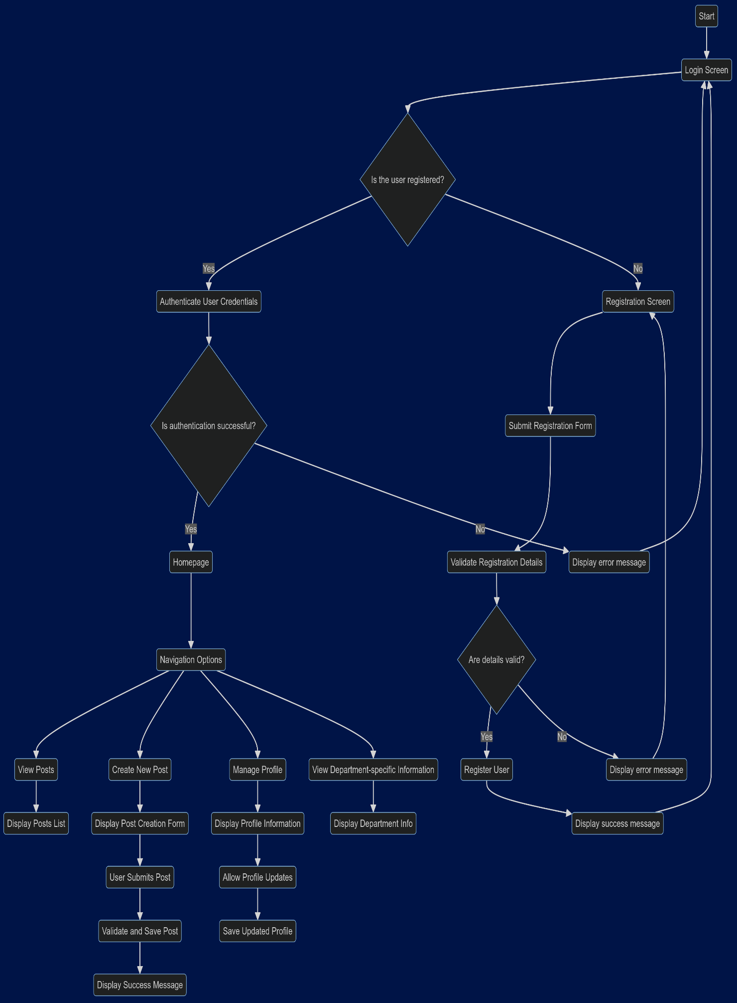

1. **Login Screen:** When users access the platform, they are greeted with a login screen where they need to enter their credentials (username/email and password). This ensures that only authorized users can access their personalized content.  
   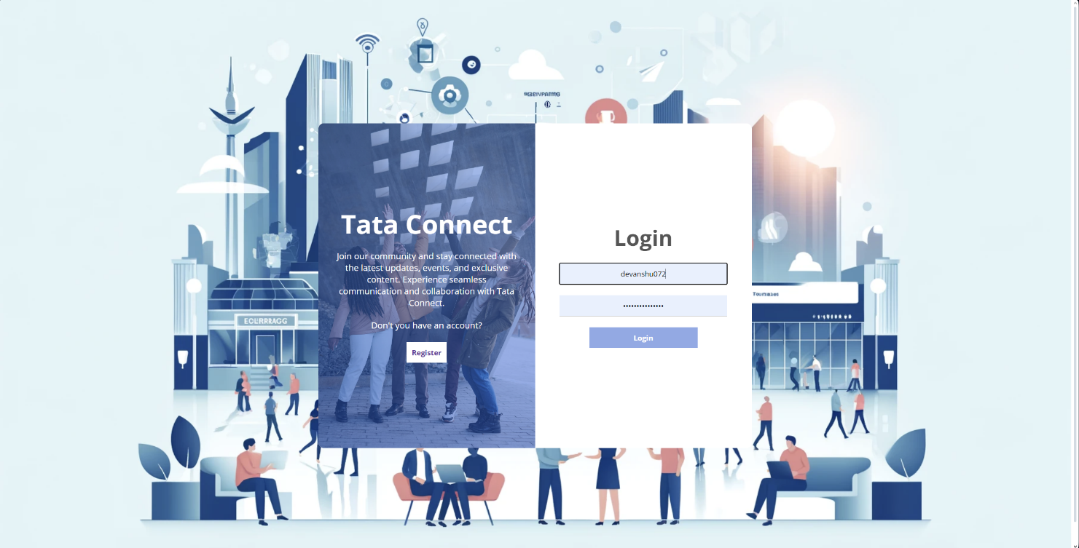



1. **Register page:** If users are not logged in, they are redirected to a registration page where they can create a new account by providing necessary details like name, email, and password. This step is essential for onboarding new users to the platform.  
     
   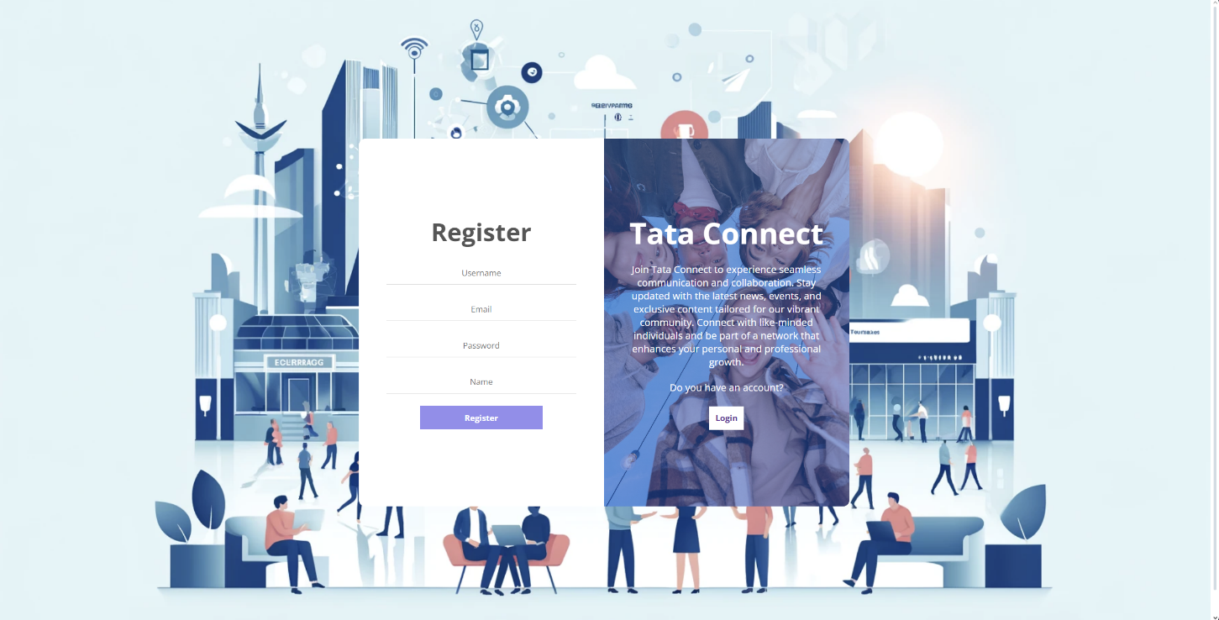



1. **User Authentication:** Upon successful login, the user lands on the Home- page, where they can see all the posts and stories here the user has the option to change the mode from light to dark.  
     
   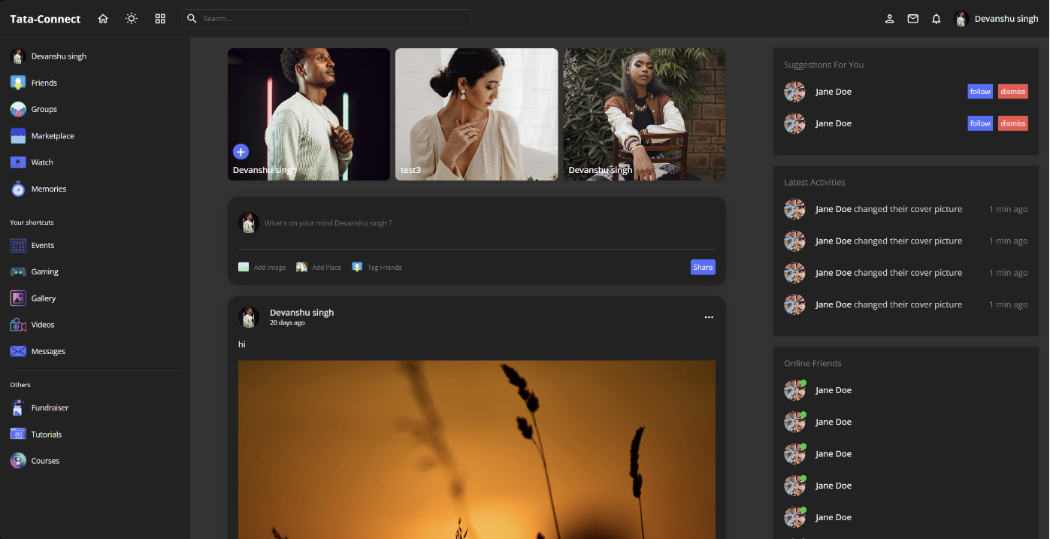  
   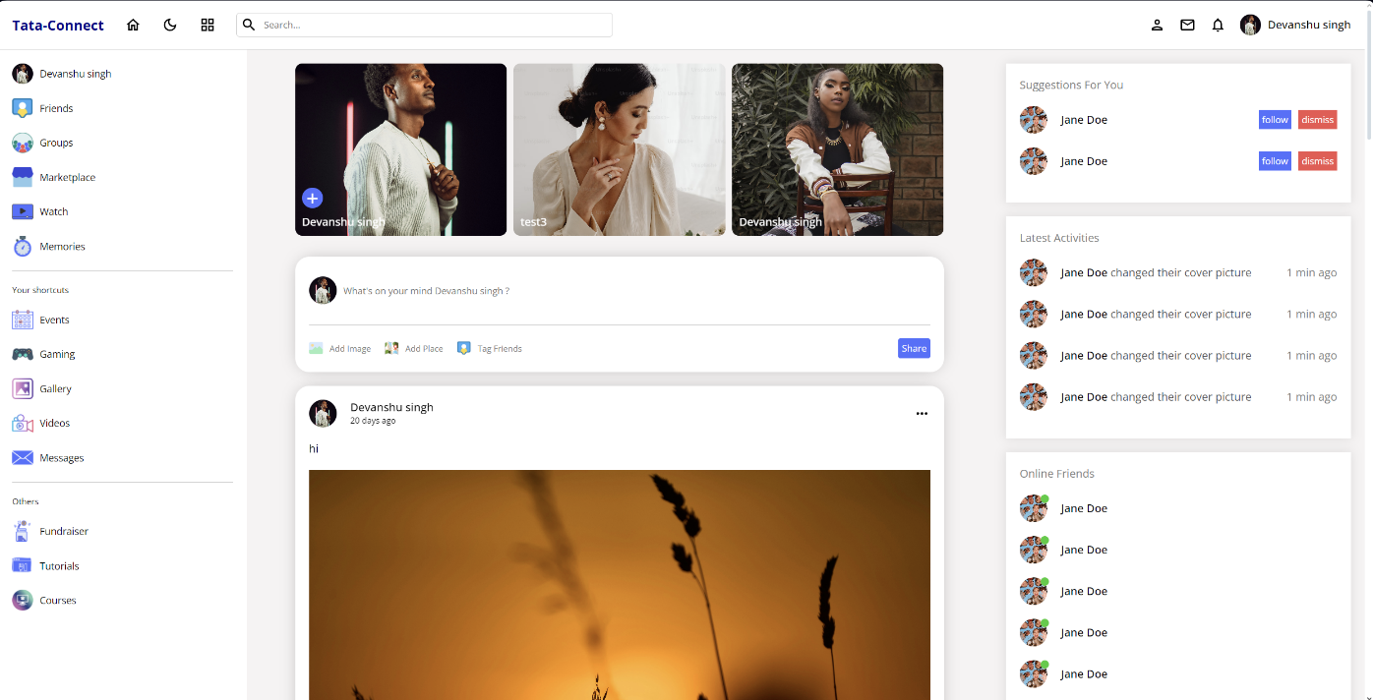



1. **Adding a new Post:** Users can easily start typing to create a new post directly from the Home screen using the create post box. They can include text and images in their posts, making it simple to share updates and media with their friends..   
   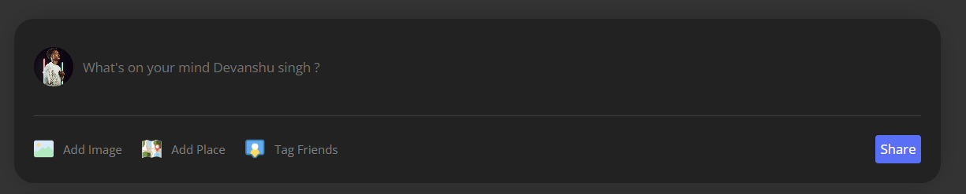



1. **A New Post is Created:** Once a user submits a new post, it is added to the feed and becomes visible to their friends and followers. The post can include both text and images, allowing for rich and engaging content.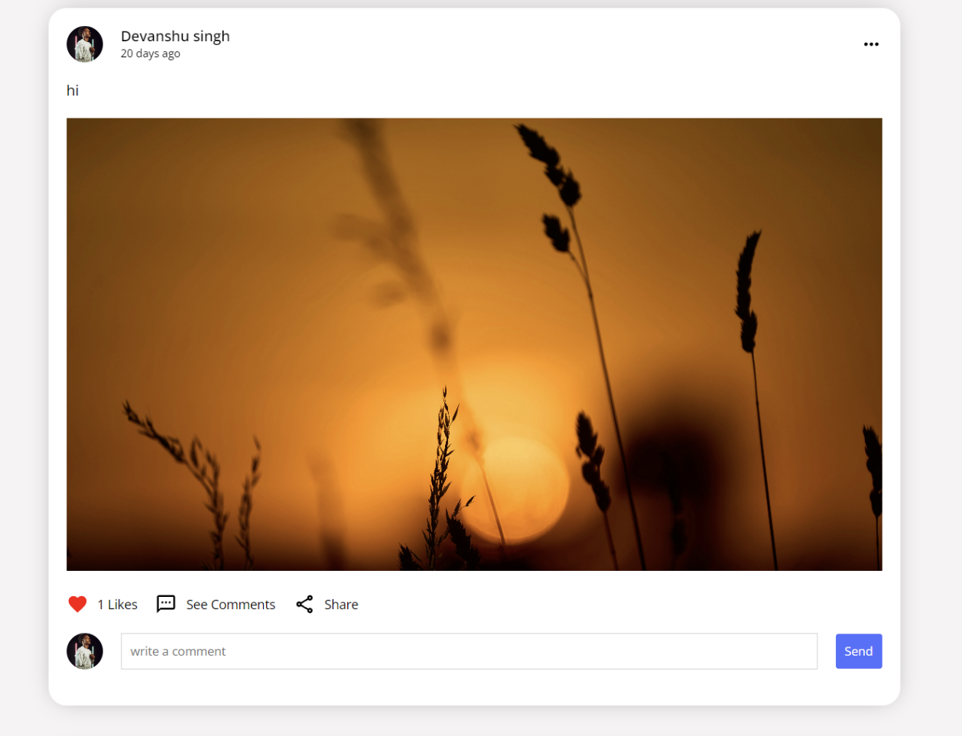



1. **Like Comment and Share:** Users can interact with posts by liking, commenting, and sharing them. This fosters engagement and allows users to express their thoughts and reactions to content shared by others.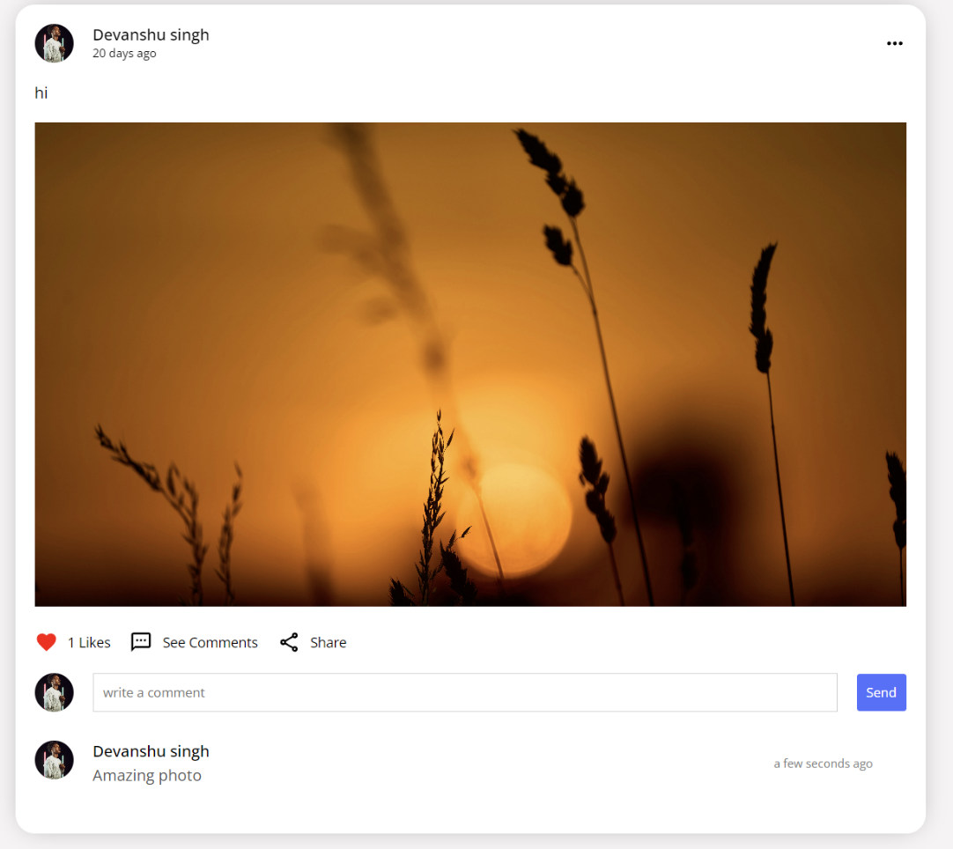  
     
   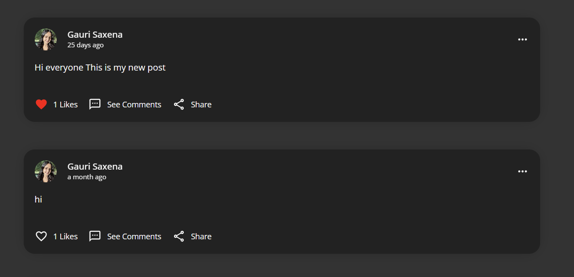
2. **Delete Post**: Users have the ability to delete posts they have shared. This gives them control over their content and ensures they can remove any posts they no longer want to be visible.  
   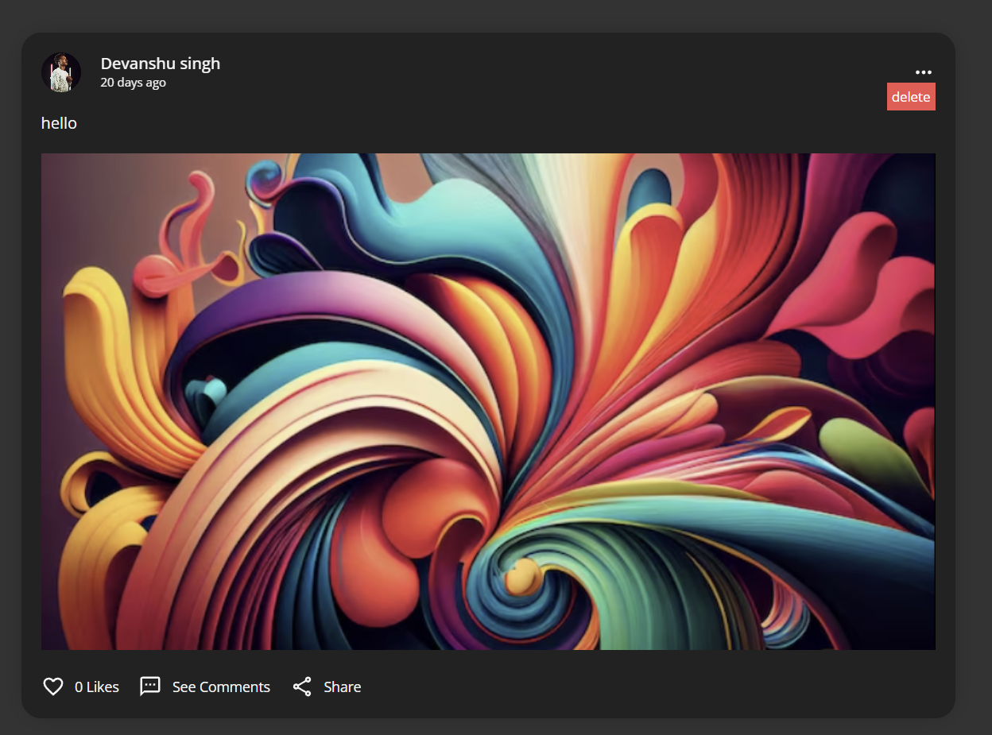



1. **Stories:** Users can view stories uploaded by their friends. Stories are typically temporary posts that provide a snapshot of recent activities and updates..  
     
   
2. **Functional Search option:** The platform includes a search function that allows users to search for any other user on the platform. This feature helps users find friends, view their profiles, and connect with new people.  
     
   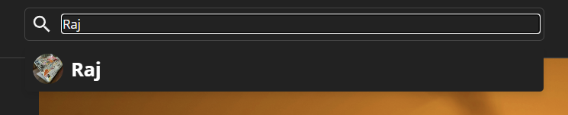



1. **Friends Profile:** Users can visit the profiles of their friends and view their respective posts. This allows for a deeper connection and understanding of what their friends are sharing on the platform.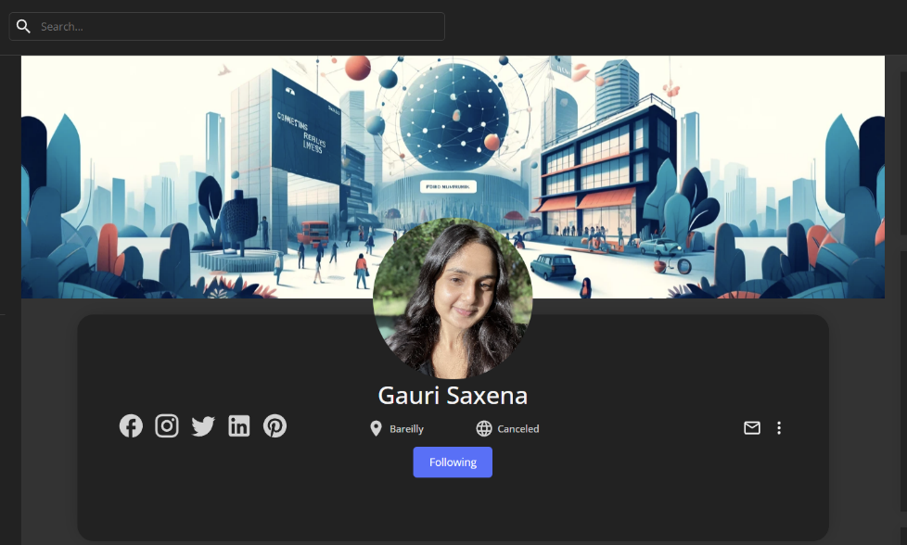



1. **User Profile:** Users can view their own profiles, which display their posts, stories, and personal information. This centralized view helps users manage their content and profile settings.  
   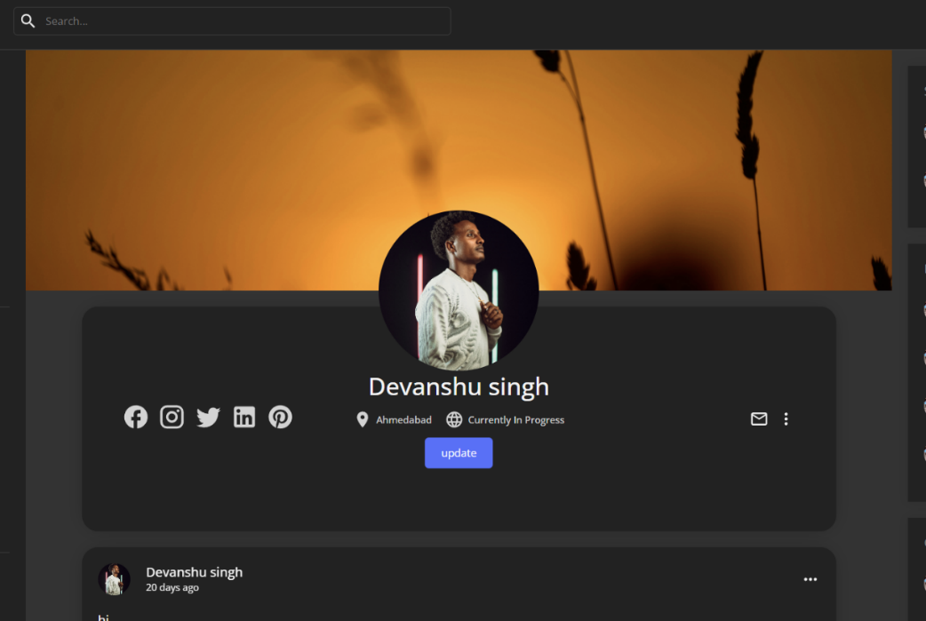



1. **Update Profile:** Users can update and alter their profiles, including their personal information, profile picture, and other settings. This ensures their profile remains current and reflective of their identity.  
   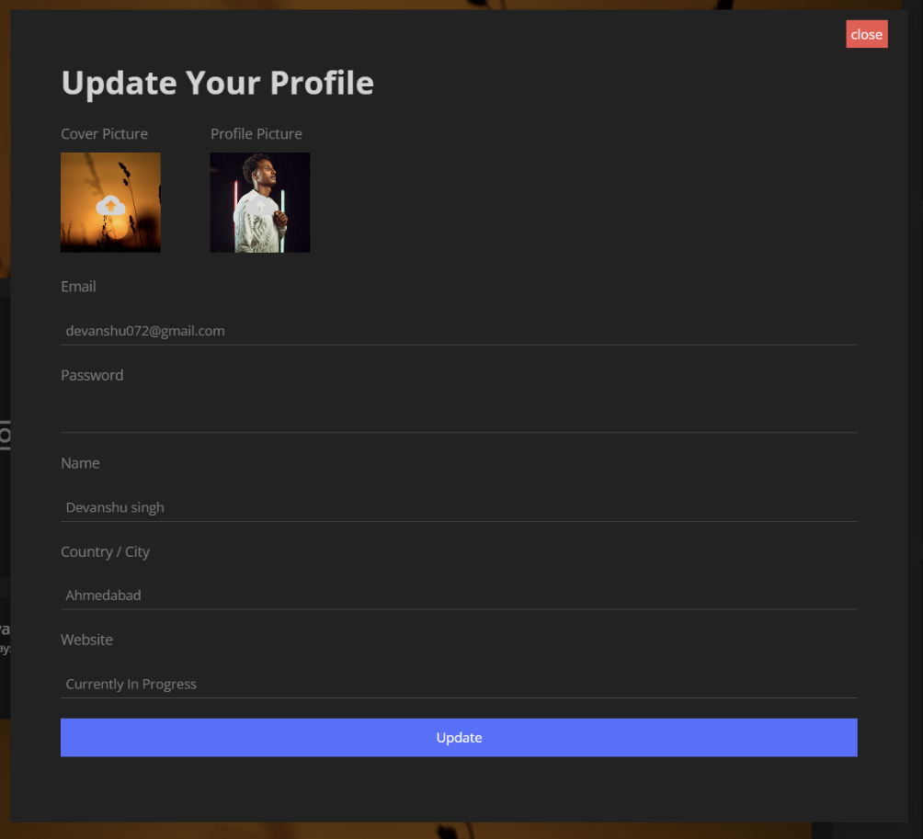

**WORK-FLOW OF THE DEPLOYMENT:**

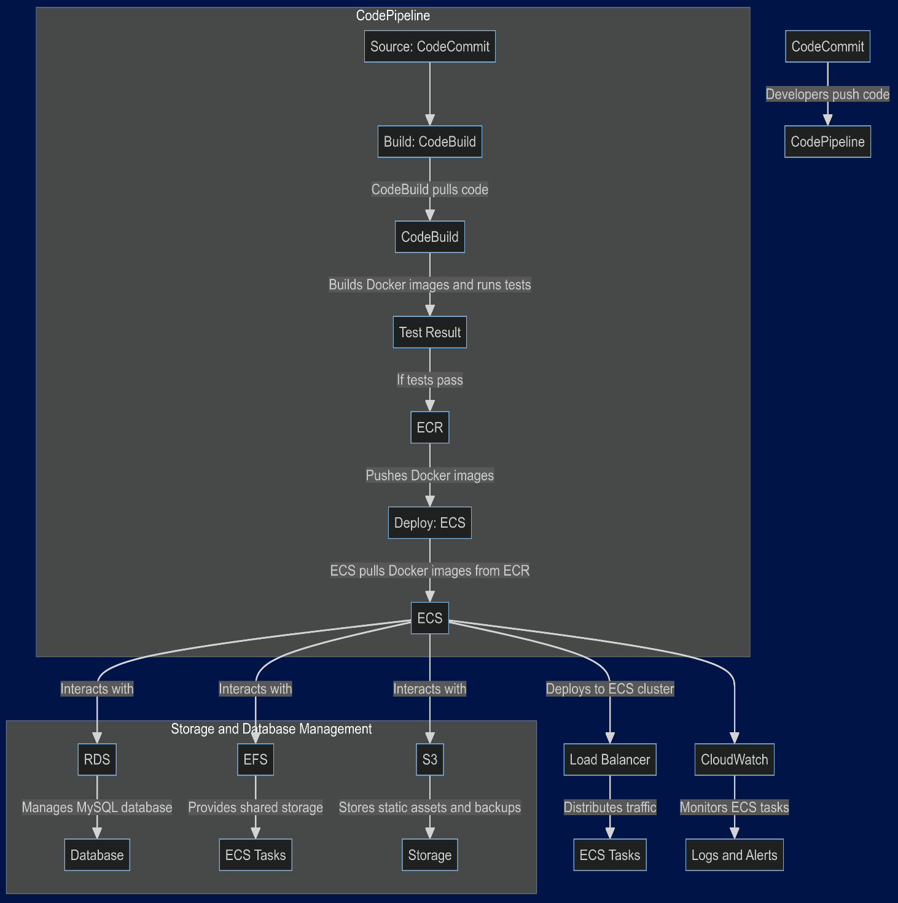

**AWS SERVICES USED FOR DEPLOYMENT:**

1. **Code-Commit**: AWS Code-Commit is utilized for version control, providing a secure, centralized repository for developers to push code changes. It integrates seamlessly with AWS Code-Pipeline to trigger automatic builds and deployments, ensuring a streamlined CI/CD workflow and maintaining high code quality.  
     
   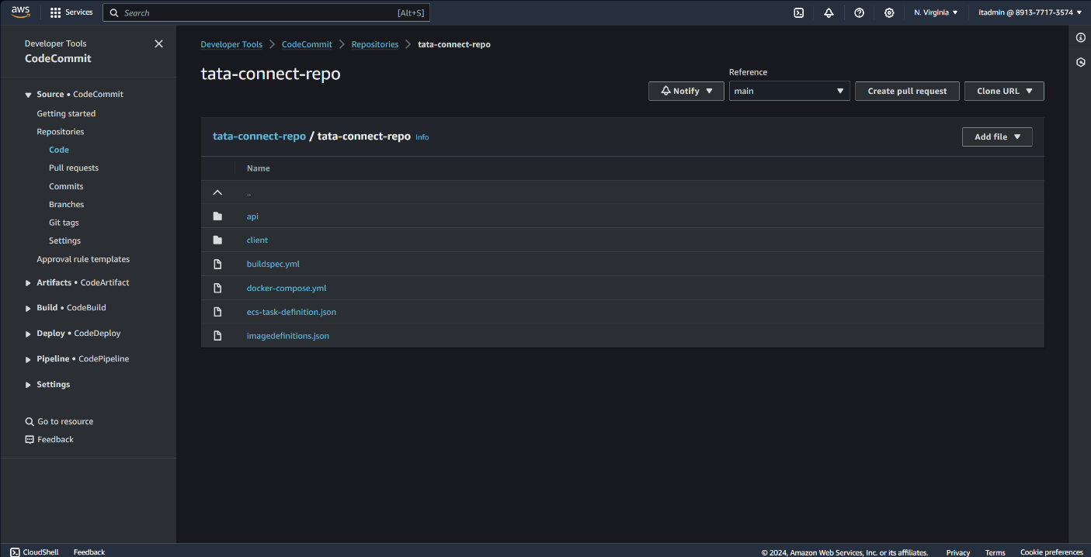
2. **RDS**: Amazon RDS manages the MySQL database for TATA-Connect, offering automated backups, patch management, and monitoring. This ensures high availability, scalability, and reduces administrative overhead, allowing the development team to focus on enhancing the application.  
     
   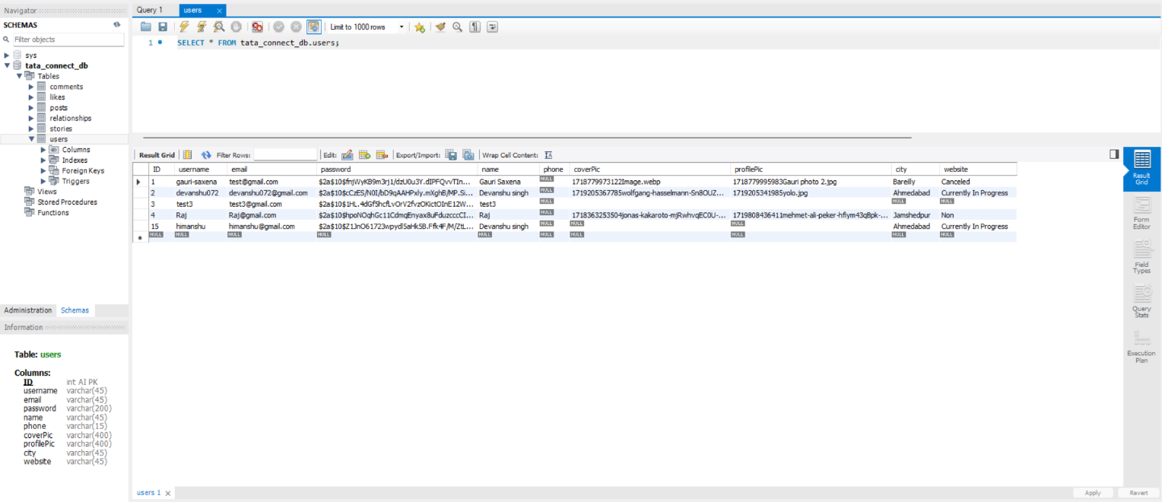  
   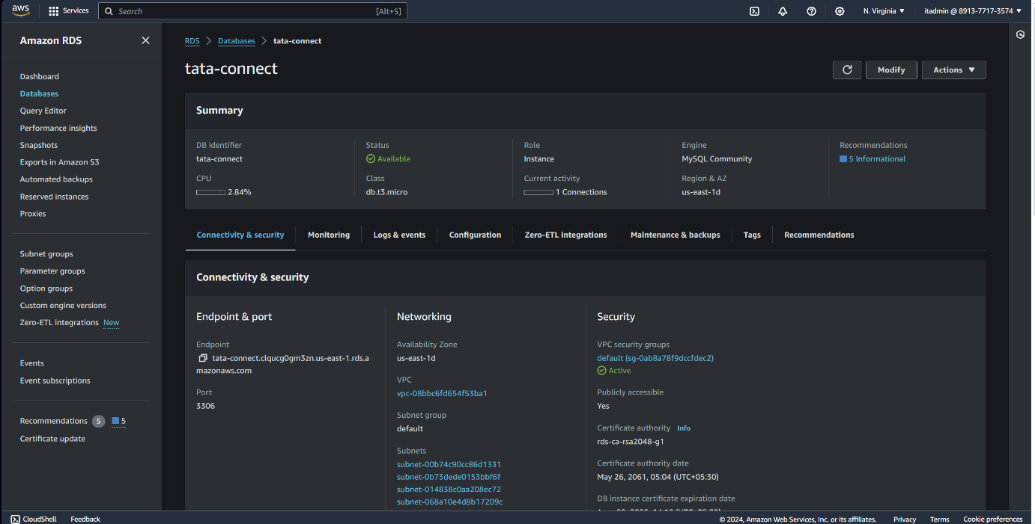
3. **Code-Build**: AWS Code-Build automates the building and testing of the application. It compiles code, runs tests, and creates Docker images, which are then pushed to ECR. This process ensures that only tested code progresses to deployment, enhancing the application's quality and efficiency.  
     
   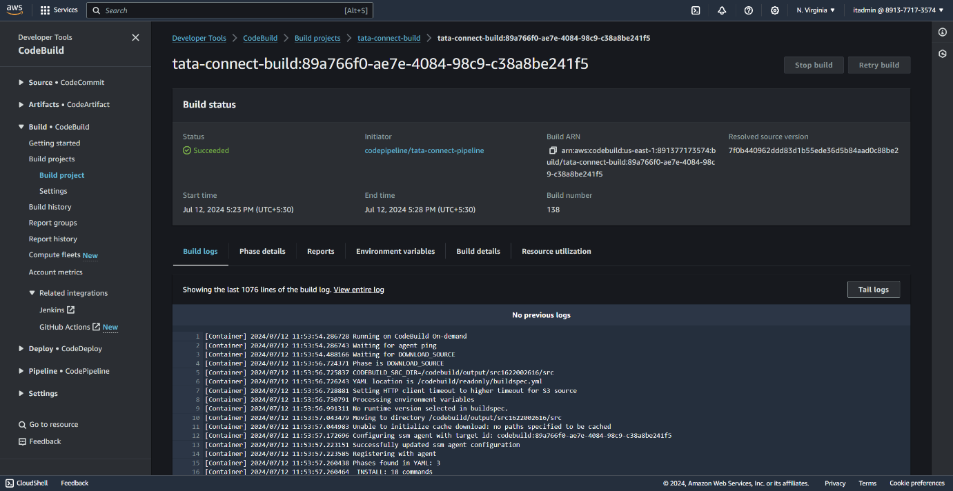
4. **Code-Pipeline:** AWS Code-Pipeline orchestrates the CI/CD process, automating the build, test, and deployment stages. It integrates with Code-Commit, Code-Build, and ECS to ensure continuous delivery of high-quality updates, maintaining the agility and responsiveness of the TATA-Connect platform. And as soon as an code is committed in the main Code-Commit repository the pipeline gets triggered and starts building on that process.

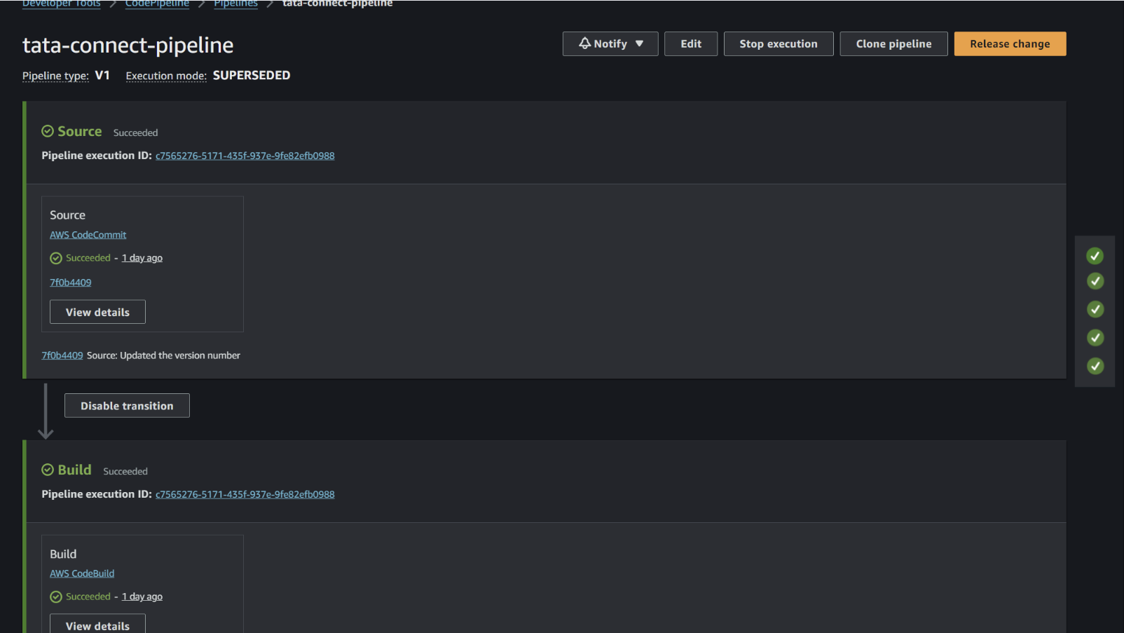

1. **ECR**: Amazon ECR stores and manages Docker container images. It integrates with ECS to facilitate secure, scalable, and reliable deployment of containerized applications, streamlining Docker image management.  
     
   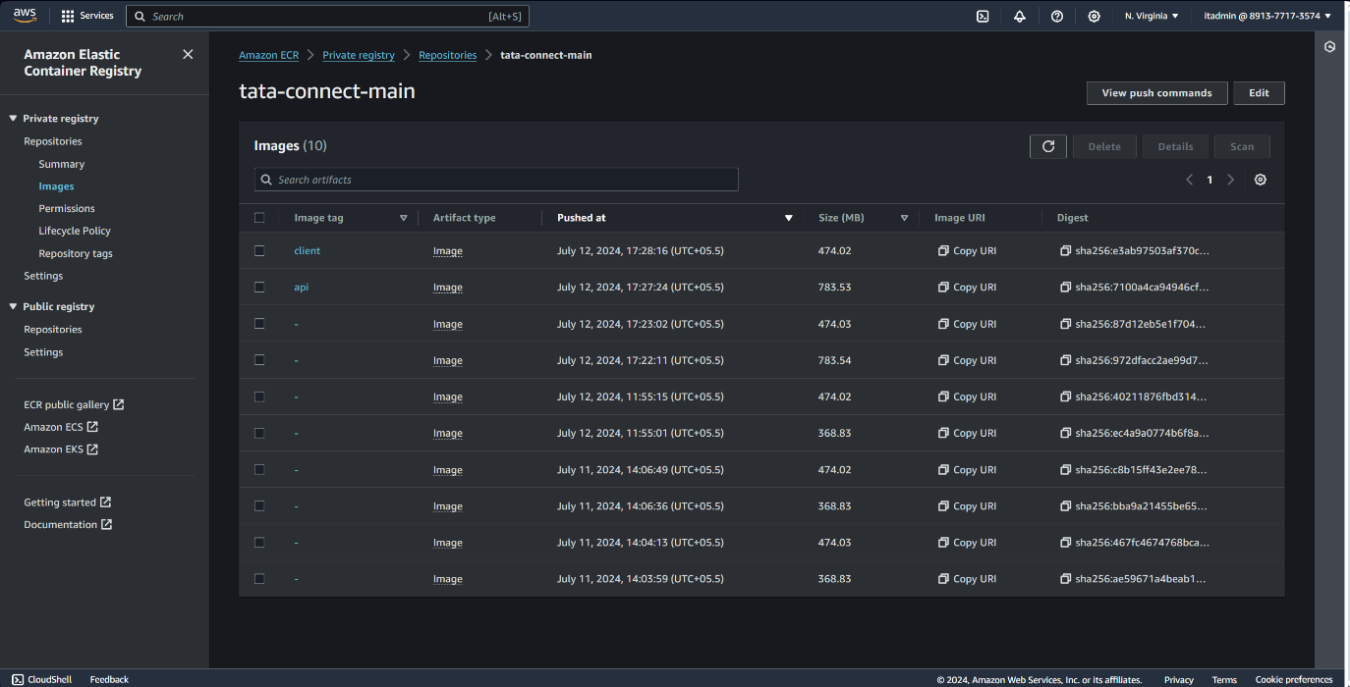
2. **ECS**: Amazon ECS orchestrates the deployment and management of Docker containers. It ensures high availability and scalability by automatically managing the containers' lifecycle, integrating seamlessly with other AWS services like Load Balancer and CloudWatch.  
     
   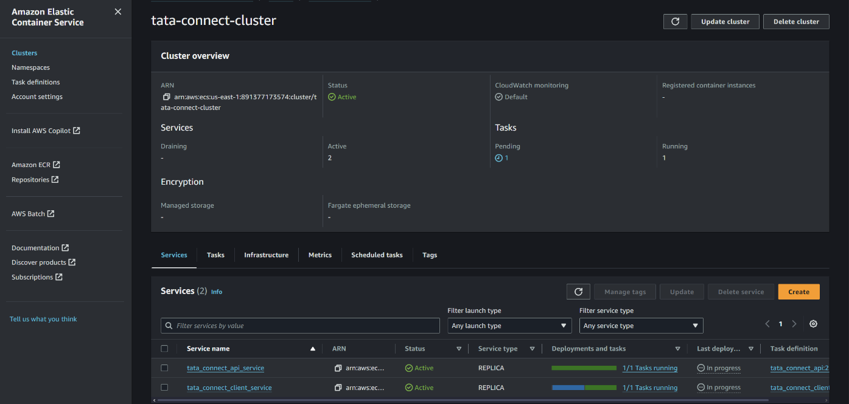
3. **EFS**: Amazon EFS provides scalable and shared file storage for ECS tasks, allowing multiple containers to access the same data concurrently. It scales automatically, ensuring consistent and reliable storage for the application's needs.  
     
   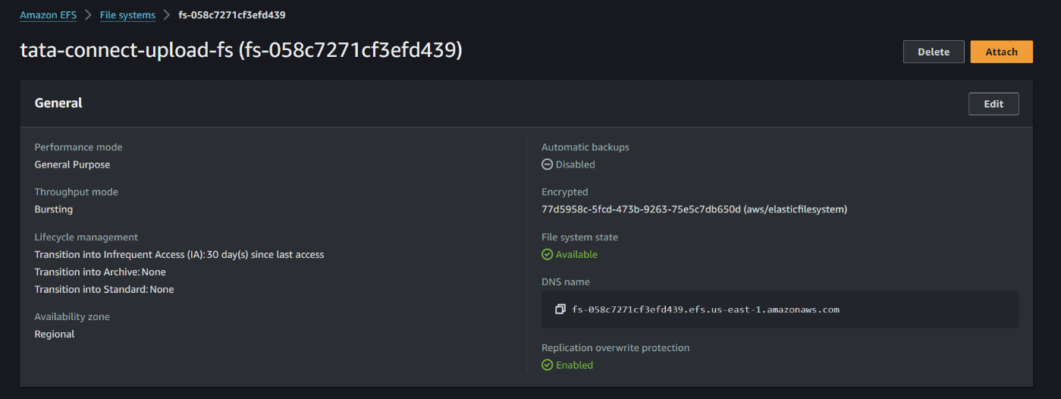
4. **S3**: Amazon S3 stores static assets, backups, and large objects, offering high durability and scalability. It handles images, videos, documents, and backups, integrating with other AWS services for efficient data management.  
     
   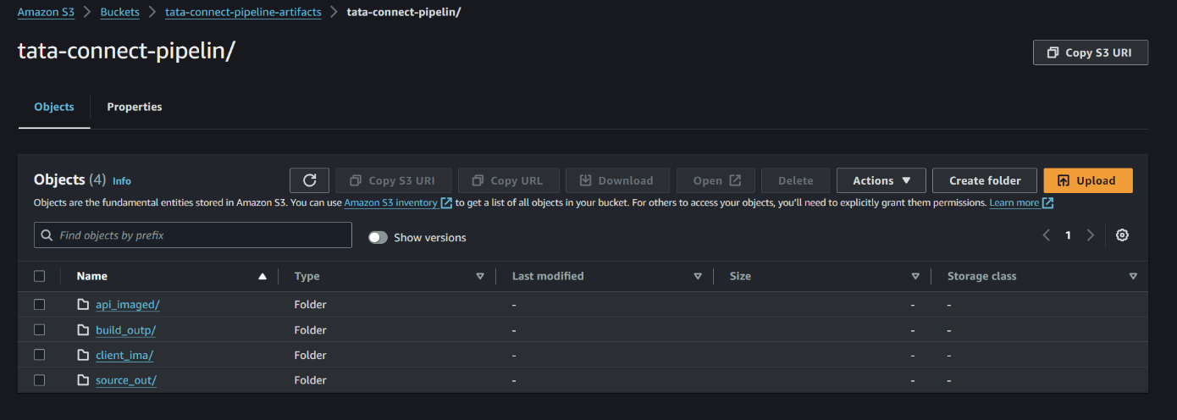
5. **Load Balancer**: An Application Load Balancer (ALB) distributes incoming traffic across ECS tasks, ensuring high availability and fault tolerance. It performs health checks and provides SSL termination, enhancing security and reliability.  
     
   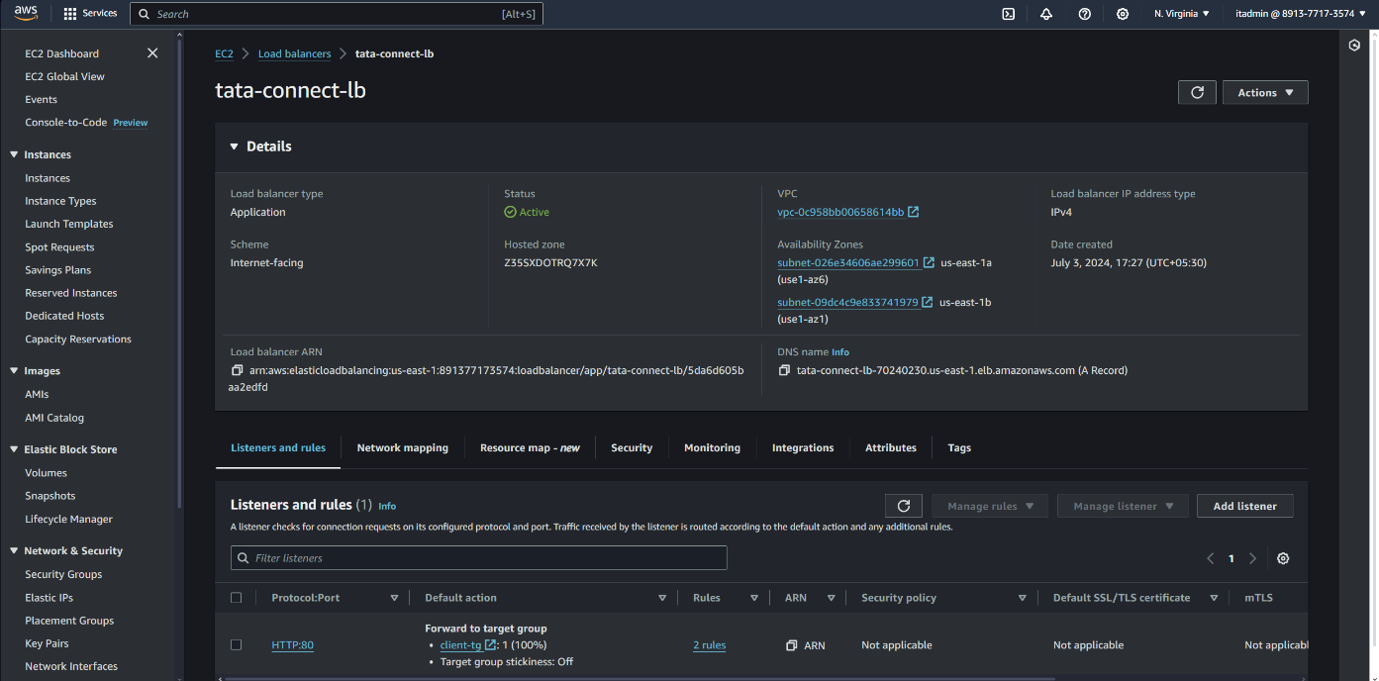

1. **CloudWatch**: AWS CloudWatch monitors application performance and health, collecting metrics and logs. It sets alarms for proactive issue detection, ensuring the TATA-Connect application runs smoothly and efficiently.  
     
   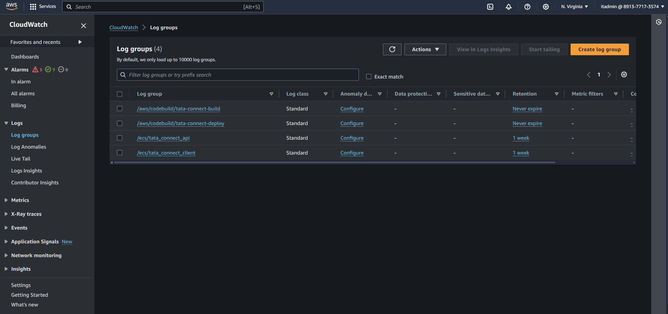

**INFRASTRUCTURE AS CODE(IaC):**

In the TATA-Connect project, Terraform has been instrumental in implementing Infrastructure as Code (IaC), significantly streamlining the deployment process and enhancing the overall development workflow. Terraform, an open-source tool by HashiCorp, allows us to define and provision infrastructure using a high-level configuration language. This approach has enabled us to manage and automate the entire infrastructure lifecycle with ease and consistency.

One of the primary advantages of using Terraform is its ability to provide a consistent and reproducible infrastructure setup. By defining the infrastructure as code, we have ensured that the environment configurations are version-controlled and can be easily replicated across different stages of development, testing, and production. This has eliminated the manual configuration errors and discrepancies that often arise in traditional deployment methods. The declarative nature of Terraform allows us to describe the desired state of the infrastructure, and Terraform takes care of creating, updating, or deleting resources to match that state. This has simplified the process of managing complex infrastructures and has provided greater control over the deployment process.

Moreover, Terraform's integration with various AWS services has been pivotal for the TATA-Connect project. We have used Terraform scripts to automate the provisioning of essential AWS resources such as EC2 instances, RDS databases, S3 buckets, ECS clusters, and VPCs. This automation has not only accelerated the deployment process but also ensured that the infrastructure is scalable and resilient. Terraform's state management feature keeps track of the deployed resources, allowing us to make incremental changes and updates to the infrastructure without disrupting the existing setup. This has been particularly beneficial in maintaining the CI/CD pipeline, as it ensures that any changes in the infrastructure code are automatically applied, tested, and deployed in a controlled and efficient manner. Overall, Terraform has significantly contributed to the robustness and agility of the TATA-Connect project by providing a reliable and scalable infrastructure management solution.

# SKILLS AND TECHNOLOGIES LEARNT AND IMPLEMENTED

### **Frontend Development:**

#### **React.js**

* **Component-Based Architecture:** Learned to create reusable UI components, which made the application modular and easier to maintain.
* **State Management:** Gained proficiency in managing the state of complex applications using hooks and context API, enhancing the responsiveness and interactivity of the application.
* **Routing:** Implemented dynamic routing with React Router to create a seamless user experience, allowing users to navigate through different parts of the application without page reloads.
* **Styling:** Utilized CSS-in-JS libraries like styled-components to manage component-specific styles, resulting in a more organized and maintainable codebase.

#### **jQuery and jQuery DataTables**

* **DOM Manipulation:** Enhanced skills in directly manipulating the Document Object Model (DOM) for dynamic content updates and user interactions.
* **Data Presentation:** Used jQuery DataTables for efficient data presentation, sorting, and pagination, which improved the usability of large data sets.

### **Backend Development:**

#### **Node.js**

* **Express Framework:** Developed RESTful APIs using Express.js, handling routing, middleware, and HTTP requests efficiently.
* **Asynchronous Programming:** Improved understanding of asynchronous programming using Promises and async/await, which is crucial for handling I/O operations in Node.js.
* **Security Practices:** Implemented security best practices, including input validation, authentication, and authorization, to protect the application from common vulnerabilities.

#### **MySQL**

* **Database Design:** Learned to design relational databases, including defining schemas, relationships, and constraints to ensure data integrity.
* **SQL Queries:** Enhanced proficiency in writing complex SQL queries for data retrieval, manipulation, and aggregation.
* **Database Optimization:** Gained experience in optimizing database performance through indexing, query optimization, and normalization techniques.

### **Cloud Computing and DevOps:**

#### **AWS Code-Commit**

* **Version Control:** Mastered the use of AWS Code-Commit for source control management, ensuring a reliable and secure repository for code storage and versioning.
* **Branching and Merging:** Learned best practices for branching and merging, facilitating collaboration among multiple developers.

#### **AWS Code-Build**

* **Build Automation:** Automated the build process using AWS Code-Build, streamlining the compilation, testing, and packaging of code.
* **Integration with CI/CD Pipeline:** Integrated Code-Build with Code-Pipeline to create a continuous integration workflow, ensuring that all code changes are tested and verified before deployment.

#### **AWS ECR (Elastic Container Registry)**

* **Container Management:** Gained experience in managing Docker images with Amazon ECR, including pushing, pulling, and versioning container images.
* **Integration with ECS:** Integrated ECR with ECS to automate the deployment of containerized applications, ensuring efficient and reliable application delivery.

#### **AWS ECS (Elastic Container Service)**

* **Container Orchestration:** Learned to use AWS ECS for orchestrating Docker containers, managing tasks, services, and clusters to ensure high availability and scalability.
* **Load Balancing:** Implemented load balancing with ECS to distribute traffic across multiple containers, enhancing the application's performance and fault tolerance.

#### **AWS EFS (Elastic File System)**

* **Shared Storage:** Used Amazon EFS for providing scalable and shared file storage accessible by multiple ECS tasks, ensuring data consistency and reliability.

#### **AWS S3 (Simple Storage Service)**

* **Object Storage:** Utilized S3 for storing static assets, backups, and other large objects, benefiting from its high durability and scalability.
* **Data Management:** Learned to manage S3 buckets, including setting permissions, lifecycle policies, and versioning to efficiently handle data storage needs.

#### **AWS CloudWatch**

* **Monitoring and Logging:** Used AWS CloudWatch to monitor application performance, track metrics, and collect logs. Set up alarms and dashboards to proactively detect and resolve issues.
* **Insight Generation:** Analyzed CloudWatch logs and metrics to gain insights into application behavior and performance, enabling data-driven decision-making.

#### **Load Balancer**

* **Traffic Distribution:** Implemented an Application Load Balancer (ALB) to distribute incoming traffic across ECS tasks, ensuring high availability and reliability.
* **SSL Termination:** Configured SSL termination at the load balancer to offload SSL processing from application servers, enhancing security and performance.

### **Continuous Integration and Continuous Deployment (CI/CD):**

#### **AWS Code-Pipeline**

* **Pipeline Configuration:** Configured AWS Code-Pipeline to automate the entire CI/CD process, from code commit to deployment, ensuring a smooth and efficient workflow.
* **Integration with Other Services:** Integrated Code-Pipeline with Code-Commit, Code-Build, and ECS to create a seamless automated deployment process.

Each of these technologies contributed to my growth as a developer. They helped me understand not only how to build a functional system but also the best practices in software development, focusing on user needs and business requirements. The knowledge gained from implementing these technologies in the Complaint Management System has been invaluable and will be a cornerstone of my future projects.

# USE CASES OF “Tata-Connect”

### *1.* ***User Registration and Authentication***

* New employee joins Tata Technologies.
* **Registration:**
  + Visits registration page, fills details, submits form.
  + Validation, account creation, confirmation email sent.
  + Employee verifies account via email link.
* **Login:**
  + Enters email and password.
  + System authenticates credentials.
  + Successful login redirects to homepage; errors prompt retry.

### *2.* ***Post Creation and Sharing***

* Employee shares an update with the department.
* **Creating a Post:**
  + Logs in, navigates to "Create Post".
  + Writes content, optionally adds media, selects target department, submits post.
* **Post Sharing:**
  + System validates, stores, and displays post.
  + Notifications sent to department members.
* **Interacting with the Post:**
  + Members view, like, comment, share.
  + Post creator engages with audience.

### *3.* ***Event Management***

* HR organizes a company-wide virtual event.
* **Creating an Event:**
  + Logs in, navigates to "Events", selects "Create Event".
  + Fills event details, marks public or private, submits.
* **Event Notification:**
  + System displays event on dashboards, sends notifications.
* **Event Participation:**
  + Employees view details, RSVP, join via event link.
* **Post-Event Interaction:**
  + Participants share feedback, post event-related content.

### *4.* ***Departmental Announcements***

* Department head makes an announcement to all members.
* **Creating an Announcement:**
  + Logs in, navigates to "Announcements", selects "Create Announcement".
  + Writes content, optionally adds attachments, submits to department feed.
* **Notification and Viewing:**
  + System stores, displays, and sends notifications.
* **Acknowledgement and Interaction:**
  + Members view, acknowledge, comment.

### *5.* ***Performance Monitoring and Feedback***

* Employees provide feedback on a any of the events that they registered through this.
* **Providing Feedback:**
  + Logs in, navigates to the Respective Post, selects that.
  + Comments the feedback and submits.
* **Addressing Feedback:**
  + Project manager responds, uses these insights for improvement of that respective project.

# TEST CASE TABLE:

|  |  |  |  |  |
| --- | --- | --- | --- | --- |
| Task | Task Details | Expected Results | Actual Results | Pass/Fail/Not Executed/Suspended |
| Login | Enter correct username and password on Login Screen | Successful login, access to Home Page. | AS EXPECTED | PASS |
| Incorrect Login | Enter incorrect username or password on Login Screen | Error message, Invalid Credentials. | AS EXPECTED | PASS |
| View Dashboard | Navigate to Dashboard after login | Dashboard view with all user-specific options visible | AS EXPECTED | PASS |
| Create Post | Navigate to "Create Post" and submit a post | Post created and visible on the feed | AS EXPECTED | PASS |
| View Post | Navigate to the department feed | Posts are displayed with like, comment, and share options | AS EXPECTED | PASS |
| Like Post | Click the like button on a post | Post's like count increases | AS EXPECTED | PASS |
| Comment on Post | Add a comment to a post | Comment appears under the post | AS EXPECTED | PASS |
| Share Post | Share a post to another department | Post is visible in the shared department's feed | AS EXPECTED | PASS |
| Edit Profile | Navigate to "Profile" and update information | Profile details updated and saved | AS EXPECTED | PASS |
| Provide Feedback | Submit feedback on a completed project via comments | Feedback recorded and is visible in comments. | AS EXPECTED | PASS |
| Edit User Details | Update the user details via update option in the user profile | User data updated in database | AS EXPECTED | PASS |
| Updating Profile photo | Using the update option, update the profile photo. | Profile Pic update on all pages. | AS EXPECTED | PASS |
| Update Cover pic | Update the cover pic in the user profile via update option | Cover pic updated and visible to all followers | AS EXPECTED | PASS |

**CONCLUSION:**

In conclusion, the development and implementation of TATA-Connect have marked a significant milestone in my journey toward enhancing internal communication and collaboration within Tata Technologies. This project has involved tackling various challenges, from designing user-friendly interfaces to establishing a robust and scalable backend infrastructure.

One critical area for improvement that can greatly enhance the effectiveness of TATA-Connect is the continuous integration of advanced features based on user feedback. While the current version provides a solid foundation for inter-departmental communication, there is a potential for further enhancements such as integrating more sophisticated analytics, personalized content delivery, and enhanced security protocols. These improvements would not only streamline communication but also provide more value to the users by addressing their specific needs and preferences.

Looking ahead, I recognize the importance of maintaining an agile development approach to ensure that TATA-Connect evolves in alignment with the dynamic needs of the organization. The implementation of a robust Continuous Integration and Continuous Deployment (CI/CD) pipeline will facilitate regular updates and improvements, ensuring that the platform remains up-to-date and responsive to user needs. Additionally, focusing on scalability will allow the platform to handle the growing number of users and increased data volumes efficiently

Moreover, this project has reinforced the importance of user-centric design and continuous improvement. By adhering to the principles of simplicity, accessibility, and responsiveness, TATA-Connect aims to deliver a user-friendly experience that meets the diverse needs of Tata Technologies' employees. The modular architecture and integration capabilities further ensure that the platform can adapt to future technological advancements and organizational changes.

In summary, TATA-Connect stands as a testament to the power of innovative thinking and collaborative effort. It has successfully addressed the limitations of previous communication platforms by providing a more cohesive and efficient solution. The knowledge and skills gained from this project will undoubtedly serve as a solid foundation for my future endeavors in software engineering and cloud computing. I am confident that with ongoing enhancements and user engagement, TATA-Connect will continue to be a pivotal tool in fostering communication and collaboration within Tata Technologies.

Thank you..!